H.T No
Regulations:
A18

Sreenidhi Institute of Science and Technology
(An Autonomous Institution)
Code No: 7F302 Date: 30-Sept-2021(FN)

B.Tech II-Year I- Semester External Examination, Sept/Oct-2021 (Supplementary)
DISCRETE MATHEMATICS (CSE and IT)

Time: 3 Hours Max.Marks:70

Note: a) No additional answer sheets will be provided.
b) All sub-parts of a question must be answered at one place only, otherwise it will not be valued.
c) Missing data can be assumed suitably.

ANSWER ANY 5 OUT OF 8 QUESTIONS. EACH QUESTION CARRIES 14 MARKS.

Bloom's Cognitive Levels of Learning (BCLL)

Remember | L1 | Apply | L3 | Evaluate | L5
Understand | L2 | Analyze | L4 | Create | L6

 |  |  | BCLL | CO(s) | Marks
1. | a) | Prove the following logical equivalences without using truth tables: ⬄ | L3 | CO1 | [7M]
 | b) | Simplify the following compound propositions using the laws of logic:  i) ii) | L3 | CO1 | [7M]
2. | a) | Suppose the universe consists of all integers. Consider the following open statements:  Write down the truth values of the following: | L2 | CO2 | [7M]
 | b) | Write down the following quantified statements in symbolic form:  - At least one integer is even.  - There exists a positive integer that is even.  - Some even integers are divisible by 3.  - Every integer is either even or odd.  - If x is even and a perfect square, then x is not divisible by 3. | L2 | CO2 | [7M]
3. | a) | Let A= {1,2,3,4,5,6,12}. On A, define the relation R by aRb if and only if a divides b, prove that R is a partial order on A. Draw the Hasse diagram for this relation. | L3 | CO3 | [7M]
 | b) | If A= {1,2,3,5,30} and R is the divisibility relation, prove that(A,R) is a lattice but not a distributive lattice. | L4 | CO3 | [7M]
4. | a) | In a class of 52 students,30 are studying C++, 28 are studying Pascal and 13 are studying both languages. How many in this class are studying at least one of these languages?  How many are studying neither of these languages? | L3 | CO4 | [7M]
 | b) | A computer company requires 35 programmers to handle systems programming jobs and 45 programmers for applications programming. if the company appoints 60 programmers to carry out these jobs, how many of these perform jobs of both types?  How many handle only system programming jobs? | L3 | CO4 | [7M]
5. | a) |  | L6 | CO5 | [7M]
 | b) |  | L6 | CO5 | [7M]
6. | a) | Verify the Euler’s formula for the planar graphs shown below  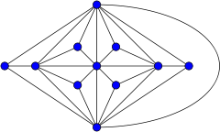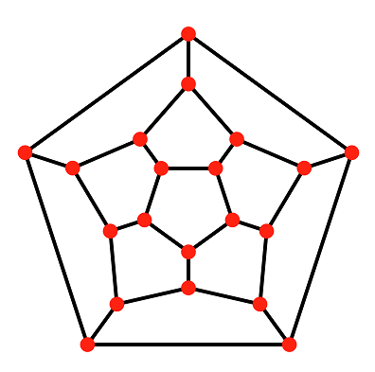  - (b) | L3 | CO6 | [7M]
 | b) | Distinguish between Euler path and Euler circuit and Find an Eulerian cycle in the graph  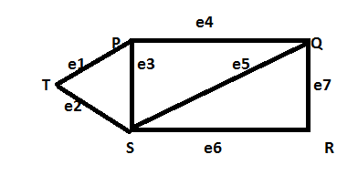 | L3 | CO6 | [7M]
7. | a) | Find the possible truth values of p,q and r in the following cases:  i) p→(q ˅ r) is false ii) p˄(q→r) is true | L5 | CO1 | [5M]
 | b) | Prove the following: | L3 | CO2 | [5M]
 | c) | Write the conditions of Group | L1 | CO3 | [4M]
8. | a) | Define Permutations and combinations with an example | L2 | CO4 | [5M]
 | b) | Solve the recurrence relation given that a_{o}=3. | L6 | CO5 | [5M]
 | c) | Find the chromatic number for the following graph  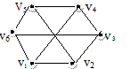 | L2 | CO6 | [4M]

-- 00 -- 00 –

